Portege Z30-E

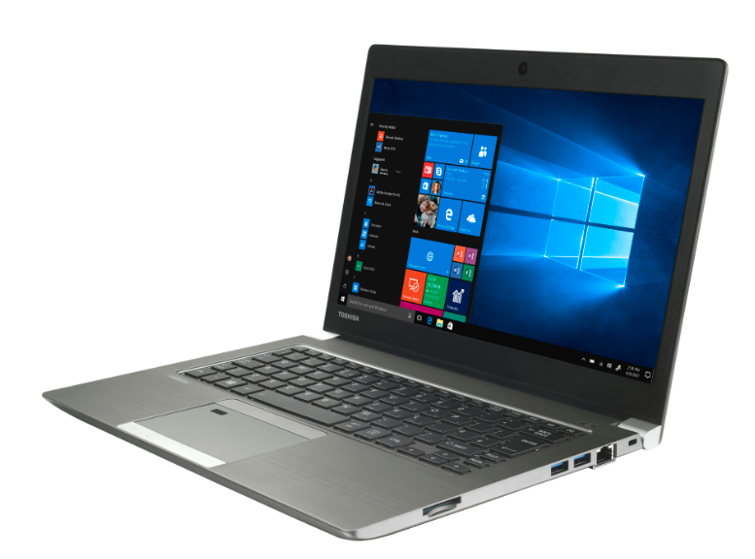

True Business Mobile Laptop
Weighing in at just 1.2kg, the Portégé Z30-E offers the latest Intel® Core™ processor and with up to 18 hours battery life, giving the laptop all the power needed to multitask on the move or in the office. The Portégé Z30-E handles business applications without compromise and with a high-performance SSD inside, means users can expect sharp speeds and fast responses all day long

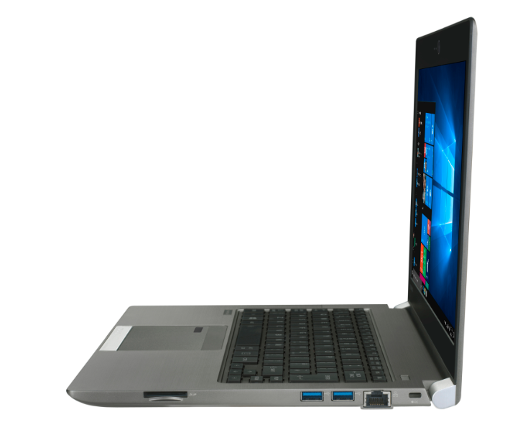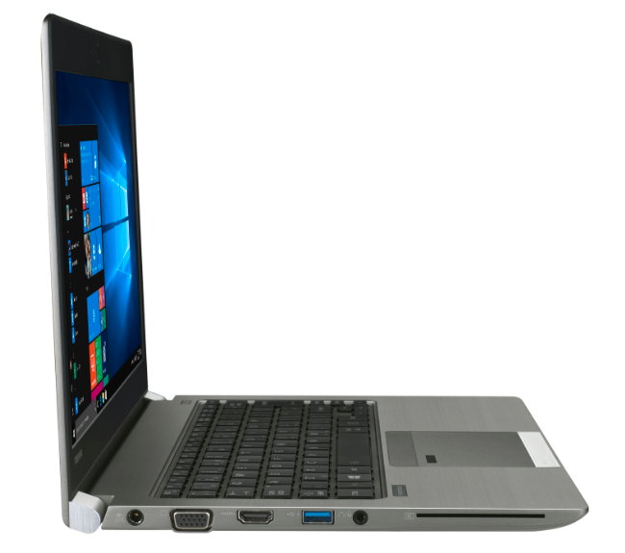
(Please label all the ports as per usual)
Convenient Connectivity

The 13.3" Portégé Z30-E is also built with complete connectivity from a range of full size ports. Three USB 3.0 ports and a HDMI port allow for work to be shared quickly or presentations projected in high-resolution brilliance. Gigabit LAN allows fast access to local networks meaning users can work wirelessly if required.

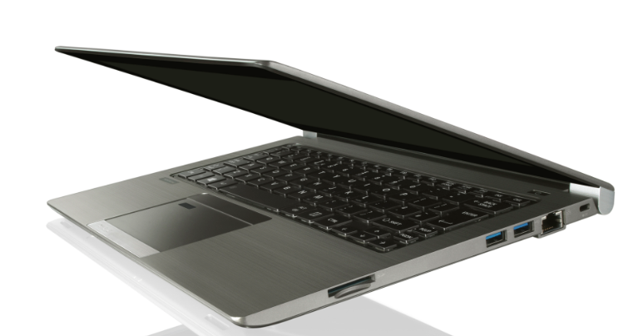

Proven Durability with Toshiba EasyGuard™ Technology
With a magnesium chassis crafted to last, and an internal Honeycomb structure to enforce its sturdiness, the Portégé Z30 comes equipped with the Toshiba EasyGuard™ Technology for an added peace of mind when it comes to bumps and drops or liquid spills while on the go.
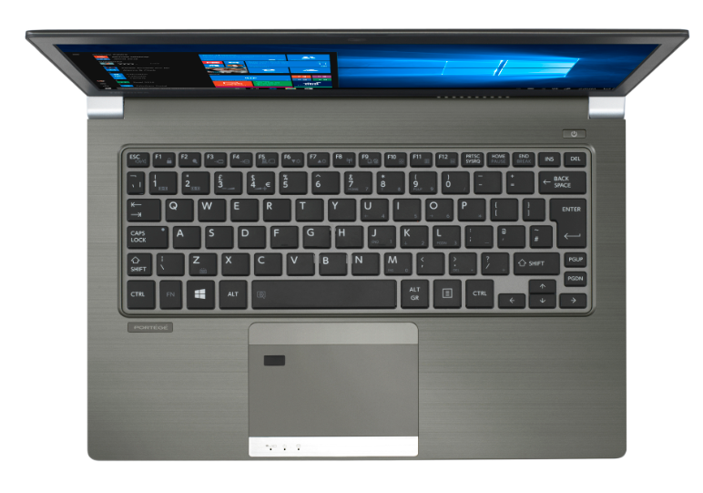
Intelligent Security for Simple Management

A Trusted Platform Module (TPM) keeps critical data safe and sound on the local storage of the Portégé Z30-E. The optional Smartcard and SecurePad™ with fingerprint reader mean that no-one but the intended user can log in. Managing the Portégé Z30-E is made easy with in-built Intel Active Management Technology (AMT) meaning IT departments can easily make updates at any time.

